cerviero

SMART HYDROPONIC FARM
White Paper
Antonello Cerviero, CEO & Founder

INTRODUCTION
The population of the Switzerland is expected to expand to exceed 10 million inhabitants in 2050, compared to the current 8 million. Especially young people and working classes are progressively developing new tastes and preferences, driving demand for processed international food products. At the same time, there is a growing frequency of eating meals outside the home as a form of socialization and entertainment.
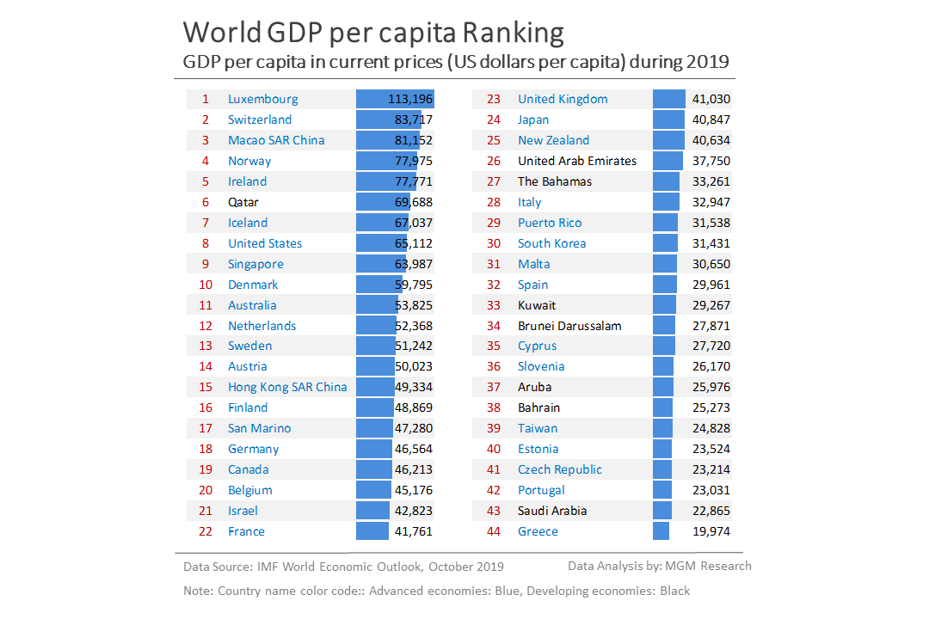

The GDP per capita of the Switzerland is estimated at over 83,717 dollars (with the same purchasing power) and is among the highest in the world. As a result, the consumption of food products benefits from the high levels of wealth in the country that fuel strong import volumes as well as foreign direct investments aimed at achieving food security for the country. The Switzerland is an essentially mountain country, with an cold climate, scarcity of arable land and a weight of the primary sector of agriculture and fisheries of less than 1 percent of GDP. As a result, the country is forced to import about 85 percent of its food needs.

THE PROBLEMS

 |  | 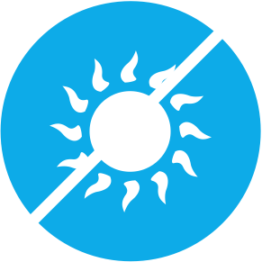
TRACEABILITY OF PRODUCTS | LAND  NOT AVAILABLE | CLIMATE CHANGE

SOLUTION

SUSTANABLE SMART AUTOMATED

WHAT IS CERVIERO
Hydroponics is a cultivation method where plants grow using nutrient solutions of minerals dissolved in water, without soil, which is replaced by an inert substrate. Which can consist of expanded clay, perlite, vermiculite, coconut fiber, rock wool, zeolite, etc. The plant produced in the nursery, is transplanted on inert supports placed at about 60 cm from the ground, anchored to the aerial structure of the greenhouse, and is irrigated with a nutritive solution composed of water and compounds, mostly inorganic, necessary to bring all the elements essential to normal mineral nutrition.
Inside the greenhouses, long rows of tomatoes, zucchini, peppers, aubergines and lettuce grow on supports spaced about one meter apart. The space needed for plant care and harvesting operations.
Carbon dioxide fertilization, which combined with oxygen and nitrogen in the air accelerate and multiply photosynthesis, allowing for lush and continuous vegetation throughout the year.
From each seedling two cuttings are grown, one towards the left, the other towards the right with respect to the support line. The two cuttings are made to twist with a thread that is fixed to the top of the greenhouse, at 4.5 meters high, to support them.
At the apex the thread is rolled up to a skein, and as the plant grows, in the lower part it is defoliated and the fruits brought to bare, and gradually reach maturation. And as the plant grows the skein is unrolled and moved 50 cm along the thread to which it is hanging. Thus the maximum height never exceeds the height to which they are hooked, and the part in maturation is always at the same height, the easiest for collection.

Those who do the lengthening of the skein, remove the axillary thalli, the leaves in excess and also perform the calibration of the bunches, removing, shortly after the setting, the supernumerary products. In this type of cultivation the quantity of water used, for the same production, is about one tenth compared to the cultivation in soil. The environmental aspect should not be underestimated since the use of fertilizers is targeted and there are no dispersions in the soil, while the use of herbicides is absent.
They do not use insecticides. But other insects, such as bees and bumblebees, that are in boxes distributed between the rows, which fight harmful insects. And where they don't come with other insects, they use baits and traps, with the basin in the picture.
Otherwise, targeted interventions with the brush are made with clay-based preparations. The essential control parameters are five:
- The first is certainly the PH. Its balance is fundamental to maintain the state of solubility of the elements and optimize the exchange processes between the roots and the nutrient solution. A PH that differs from the optimal range worsens the nutritional status of the plants due to the chemical or physiological immobilization of one or more mineral elements.
- The concentration of the nutrient solution is controlled by controlling the electrical conductivity. A low conductivity is correlated to an excessive dilution of the solution, therefore the plants are in conditions of deficient mineral nutrition.
- Flow rate, timing and dispensing cycles: Mineral nutrition control is done through the correct management of the flow rate and timing of the nutrient solution, which regulates the exchange of the solution in contact with the roots.
- With the chemical composition of the solution, the nutritional balance of the plants compared to the various nutrients, the antagonism ratios between potassium and alkaline-earth metals and the solubility of the various salts are controlled. Since the plants require different fertilization ratios in relation to the species, the type of production and the quantitative and qualitative yield ratio of the product, the composition of the solution is fundamental for achieving the objectives.
For the preparation of the solutions, fertilizers with high solubility in water must be used.
- Finally we have control of temperature and humidity inside the greenhouse.

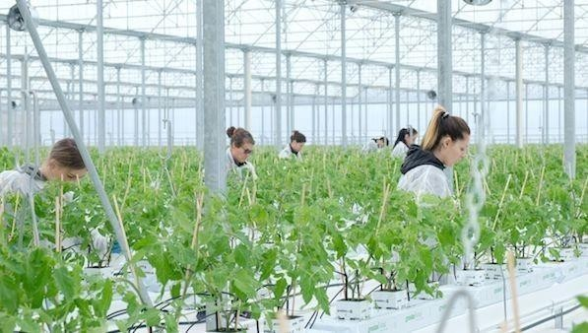WHAT IS
HYDROPONIC CERVIERO IS A CULTIVATION AND IRRIGATION INNOVATIVE SYSTEM THAT ALLOWS PLANT CULTIVATION ONTO THE GROU ND AND OUT THE EARTH.
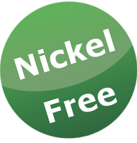
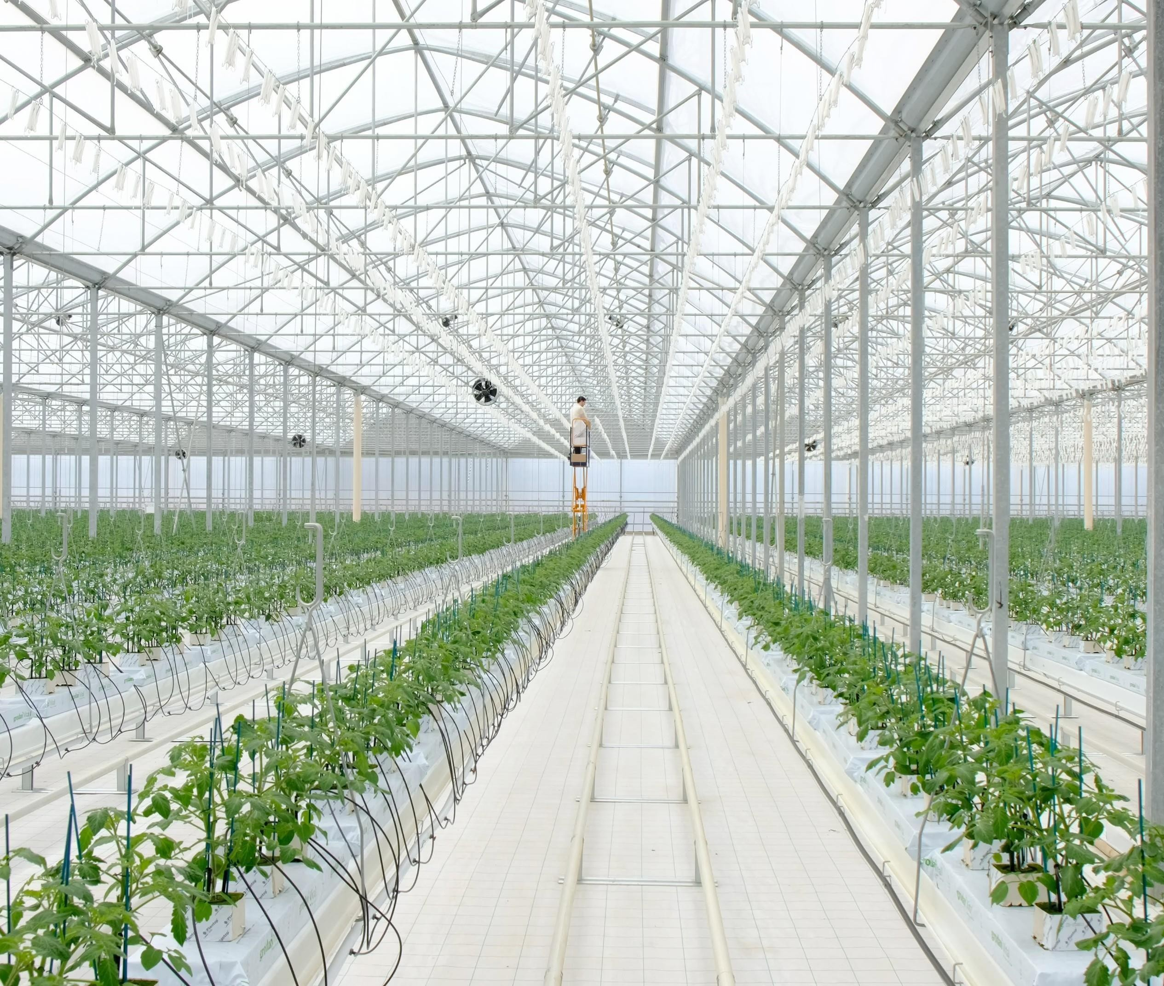

WHY CERVIERO
THE INNOVATION OF CERVIERO SYSTEM RESIDES IN THE INTERNET OF THINGS, THAT IS THE CAPACITY TO MAKE ALL COMPANY SOFTWARE AND HARDWARE INFORMATIC SYSTEM INTELLIGENT AND FULLY CONNECTED BETWEEN EACH OTHER.

WE BELIEVE THAT IT IS A FARMING SOLUTION, BENEFICIAL WELL SUITED FOR THE UAE´S CLIAMTE, ITS CONSUMERS, AND ALSO HAS THE POTENTIONAL TO THRIVE IN THE MARKET.

STRENGTHS

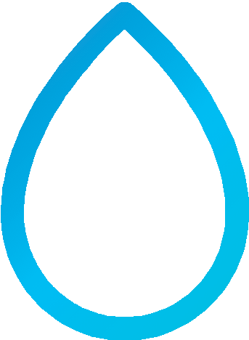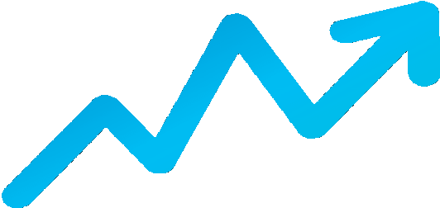

500%
MORE PRODUCTIVITY THAN EARTH CULTURES
90%
LESS OFWATER CONSUMPTION
50% FASTER GROWTH

OTHER IMPORTANTSTRENGTHS

40% LESS WORK 30% LESS ENERGY 100% ORGANIC
REQUIRED FERTILIZERS

BIODEGRADABLE PACKAGING
CONSTANT AND CONTROLLED PRODUCTION THROUGHOUT THE YEAR

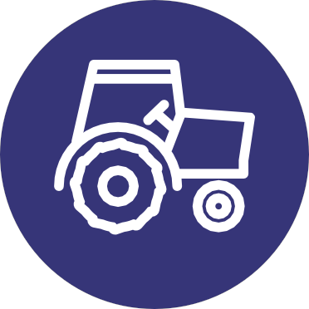
KM ZERO

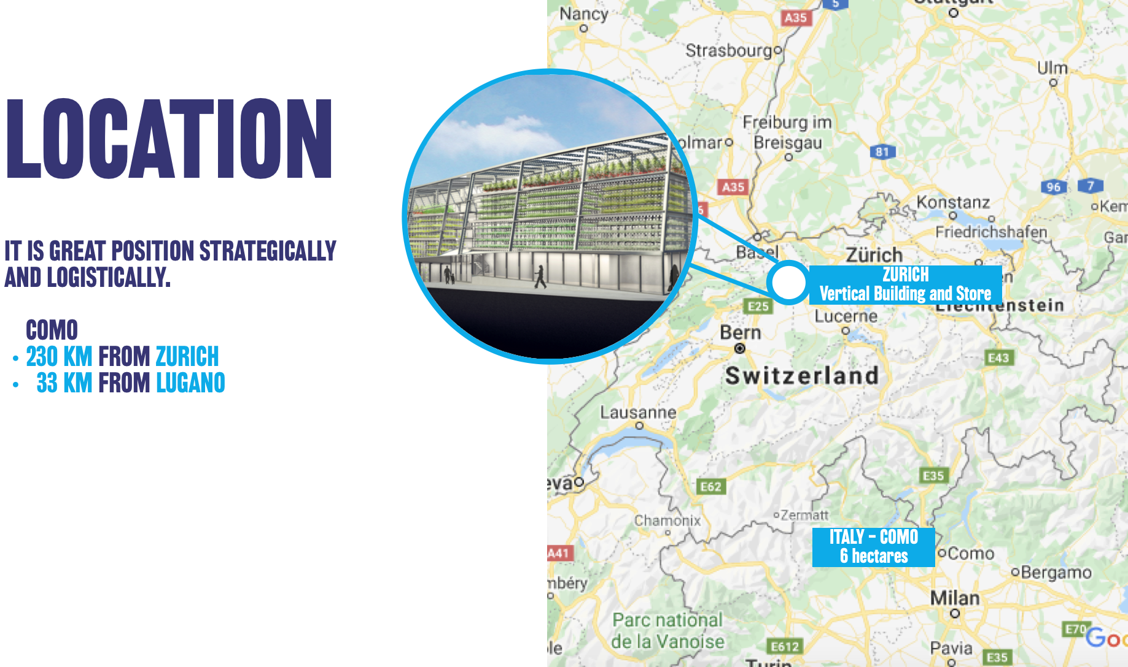

BLOCKCHAIN
It is a secure transactional register, shared by all the parts that operate within a given distributed network of computers connected to each other via the
Internet, through a dedicated application that allows interfacing with the "chain", made up of data blocks that store transactions.
It records and archives all the transactions that take place within the network, through a validation process that guarantees its authenticity and integrity, thanks to the mechanism of distributed consent.

THE CHARACTERISTICS OF THE BLOCKCHAINS
Digital. Currency, contracts, documents, inthe Blockchain everything becomes digital and the transactions included in the chain can relate to any asset, any right or container of value and information.
Safety. Thanks to the encryption process that characterizes it, it is not possible to change or make changes to the blocks already inserted in the chain; the data saved in it are therefore safe, certain and not manipulable.
Trusted. Being chronologically organized (the blocks are added to the chain according to a precise and unchangeable chronological order) it prevents the emergence of disputes regarding the execution, for example, of the different phases of a contract.
Reliable. Its technical characteristics prevent any loss of data or damage: if even one of the nodes in which the chain is saved is damaged, the others will continue to function keeping the chain stable, without any loss of data.
Fast. It does not require a central entity that verifies its congruity and validity, this occurs by consensus of the network, and being a completely digital solution eliminates execution times, checks, paper, back-office and operational risks.

WHY THE BLOCKCHAIN IN AGRIFOOD?
Blockchain technology is born in the financial sector but its application has an even greater potential if applied to industry and, in particular way, to food:

COUNTERFEITING - $ 600 billion total$ 65 billion for «Italian Sounding», of which $ 27 billion only inthe United States (data: Federalimentare) WASTE AND INEFFICIENCY OF THE SUPPLY CHAIN - 1.3 billion tons of waste. That is 33% of world food production (data: FAO - UN) CYBERSECURITY - 74% of the world's companies will be hacked every year (Brad Smith - Microsoft)

The unconditional trust of consumers in food products has long been compromised by numerous scandals (Horse Meat, Brazilian Meat for to mention a few) and the demand for full traceability is becoming stronger.
Companies can no longer rely on generic terms such as "healthy" or "organic" to signal value: the new generation of consumers wants to know the history of food in an "also" that is not printed on the label, otherwise it goes to look elsewhere.
The Blockchain provides a method to validate these previously unfounded claims, strengthening customer loyalty for those companies that can constantly guarantee the quality of their products.

Through the use of a simple QR Code and a smartphone, customers can scan a package at the point of sale and receive a complete and complete chronology of their food path "From Farm to Fork".
This is particularly useful in gray areas of food traceability such as country of origin labeling.

FOOD SAFETY AND BLOCKCHAIN
Blockchain makes the supply chain more transparent to a whole new level. Furthermore, it allows the whole chain to be more responsive to any food safety incident.

Walmart, which sells 20% of all food in the United States, has recently completed two pilot blockchain projects.

Before using Blockchain, he conducted a traceback test on mangoes in one of his stores. It took six days, 18 hours and 26 minutes to trace the mangoes from the farm of origin.

Using Blockchain, it can provide all the information the consumer wants in 2.2 seconds.

PREVENT FRAUD
Most compliance data is currently verified by reliable third parties and stored on paper or in a centralized database.
These databases they are extremely vulnerable to informational inaccuracies, hacking, high operating costs and intentional errors motivatedby corruption and behavior fraudulent.
Blockchainoperatesanonymously,records aremaintainedpermanently, so errorsare attributable totheindividualculpritsand thisfunction it is not at all trivial for the search for responsibilities and for the solution of crises.

FAIR PAYMENT AND FASTER
Blockchain allows all supply chain actorsto be paid faster asmarket data would be readily available and validated, preventing the coercionof prices and retroactive payments, common in the food supply chain.
Blockchain technologies could "Uberize" the agri-food sector by eliminating intermediaries and lowering transaction fees. This can lead to fairer pricing and even help smaller companies to find more attention to the market.

BLOCKCHAIN TECHNOLOGY INTEGRATION
INTEGRATION OF BLOCKCHAIN TECHNOLOGY AS A TRACEABILITY SYSTEM FOR THE POST-PRODUCTION PRODUCT
COLLECTION
QUALITY
VERIFICATION
LOGISTIC
RETAILER
HAPPY
GROWER CONSUMERS
CERTIFICATED SENSOR CONTROLS
CERTIFICATED SENSOR CONTROLS
BLOCKCHAIN QUALITY CERTIFICATE
LOGISTIC SENSOR CONTROL
FINAL QR CODE
(CONTAINS ALL THE INFORMATION ABOUT THE PRODUCTION CHAIN OFTHEITEM FOR SALE)

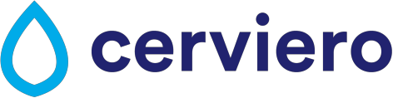
INFORMATION PRINTED ON THE BLOCKCHAIN (IMMUTABLE) AS A GUARANTEE OF THE PRODUCTION AND SUPPLY CHAIN

OPEN SOURCE
DASHBORD
A CONTROL PANEL CAPABLE OF SHOWING ALL THE DATA IN REAL TIME AND TRACKING ON THE BLOCKCHAIN

ITS HIGHLY FUNCTIONAL BLOCKCHAIN INTEGRATION TECHNOLOGY, EASY TO USE AND SECURE.
WELCOME TO CERVIERO DASHBOARD

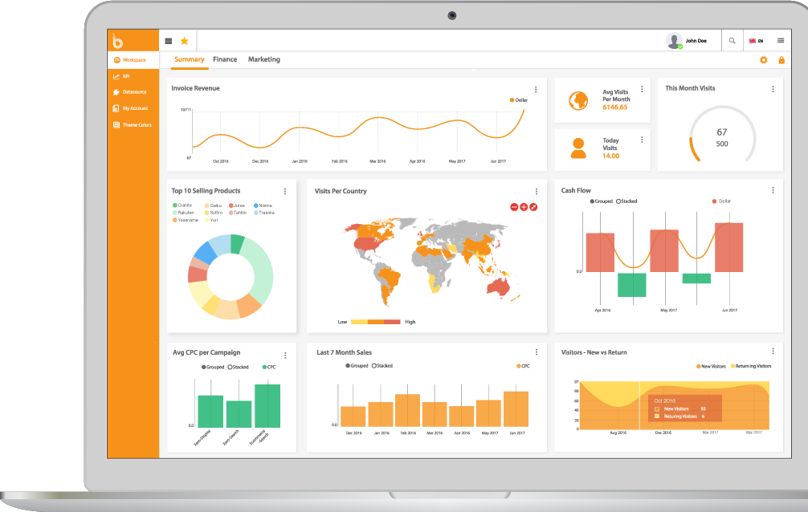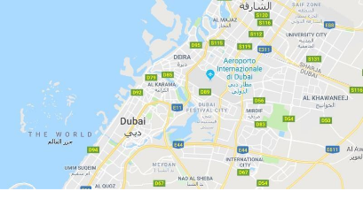Main Blockchain Token Orders
LOGISTIC TRACKING

GROWER DISTRIBUTION

MONTHLY PRODUCTIVITY
ENERGY CONSUMPTION

1.190
CERTIFICATED RETAILERS

GENERAL DISTRIBUTION
GENERAL MONTHLY REPORT

COMPANY PRODUCTION CAPACITY

37.401
USERS

THE DASHBOARD WILL SHOW DATA ON PRODUCTION, DISTRIBUTION, WAREHOUSE, COMPANY PRODUCTION CAPACITY, PRODUCT QUALITY, PRODUCT CHARACTERISTICS, ETC…

OURMISSION
TRANSPARENCY FIRST

THE TOKEN (AQUA) AS PAYMENT SYSTEM

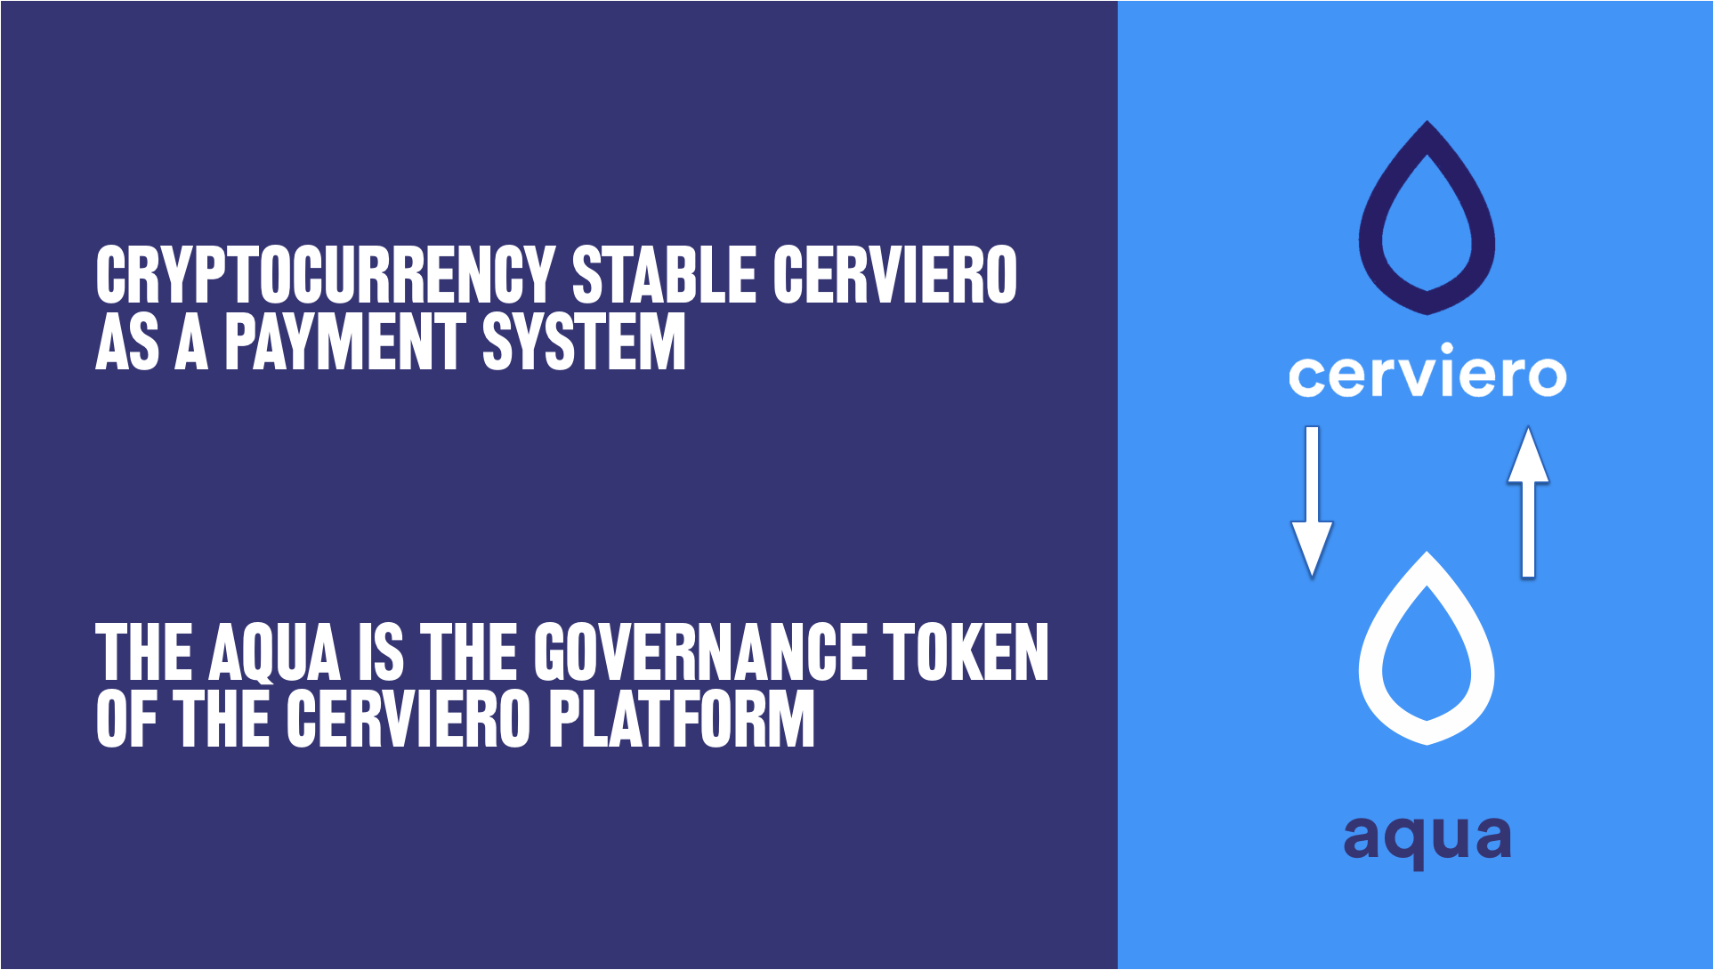

MAIN CHARACTERISTICS OF TOKEN UTILITY:

NAME: AQUA
TYPOLOGY: UTILITY TOKEN TOTAL SUPPLY: 100.000.000

MAIN CHARACTERISTICS OF STABLECOIN:

NAME: CERVIERO
TYPOLOGY: STABLECOIN

INTEGRATION OF BLOCKCHAINTECHNOLOGY
AS A PAYMENT SYSTEM BETWEEN MANUFACTURER AND DISTRIBUTOR
RETAILER1
RETAILER 2
RETAILER X
CERVIERO
COMPANY
CERVIERO AUTOMATIC BLOCKCHAIN PAYMENT SYSTEM BY IOT

*FOR CERVIERO STABLECOIN PAYMENTS IT WILL BE POSSIBLE TO HAVE A DISCOUNT ON THE FINAL PRICE (10% DISCOUNT)

CROWDSALE DETAILS
The Aqua crowdsale and the corresponding token creation process will be issued by CERVIERO, a Switzerland, and will be organized around
smart contracts running on Ethereum.
Participants willing to support the development of the Aqua Project can do so by sending via the exchange launchpad. By doing so, they are purchasing Aqua Tokens (AQUA).

- The accepted currency is Ether, Bitcoin and USDT.
- The creation will be capped upon receipt of 2.400.000 AQUA Token equivalent to USD 24m.
- Token Creation has a hard cap: upon achieving this cap, token creation will stop and no further contributions will be accepted. The hard cap amount is USD 24m.

Issuer CERVIERO | Jurisdiction of Issuance Switzerland
Legal qualification | Utility Coin, not a security
Hard Cap | USD 24m
Maximum number of tokens generated | 100.000.000
% of tokens generated to Cerviero team | 40%
% of tokens generated for future company financing | 57,6%
Date of crowdsale start | January 2021

AQUA Tokens

The AQUA token will be an Ethereum-based token of value. The token is a digital asset, bearing value by itself based on its underlying assets, properties and/or associated rights.
Ethereum-based tokens rely on a well-established Ethereum infrastructure, benefiting from several advantages:
  - Security and predictability (as opposed to, for example, having to run an independent blockchain network).
  - Use of robust and well-supported clients (Ethereum-based tokens can be managed with official Ethereum clients).
  - High liquidity (interchangeable with other Ethereum-based tokens or Ether), easier listing on exchanges with infrastructure already in place.

Our Ethereum-based token contract complies with the ERC20 standard.

INCENTIVE PROGRAM

You can even get a 10% discount if you use AQUA coin to pay product.

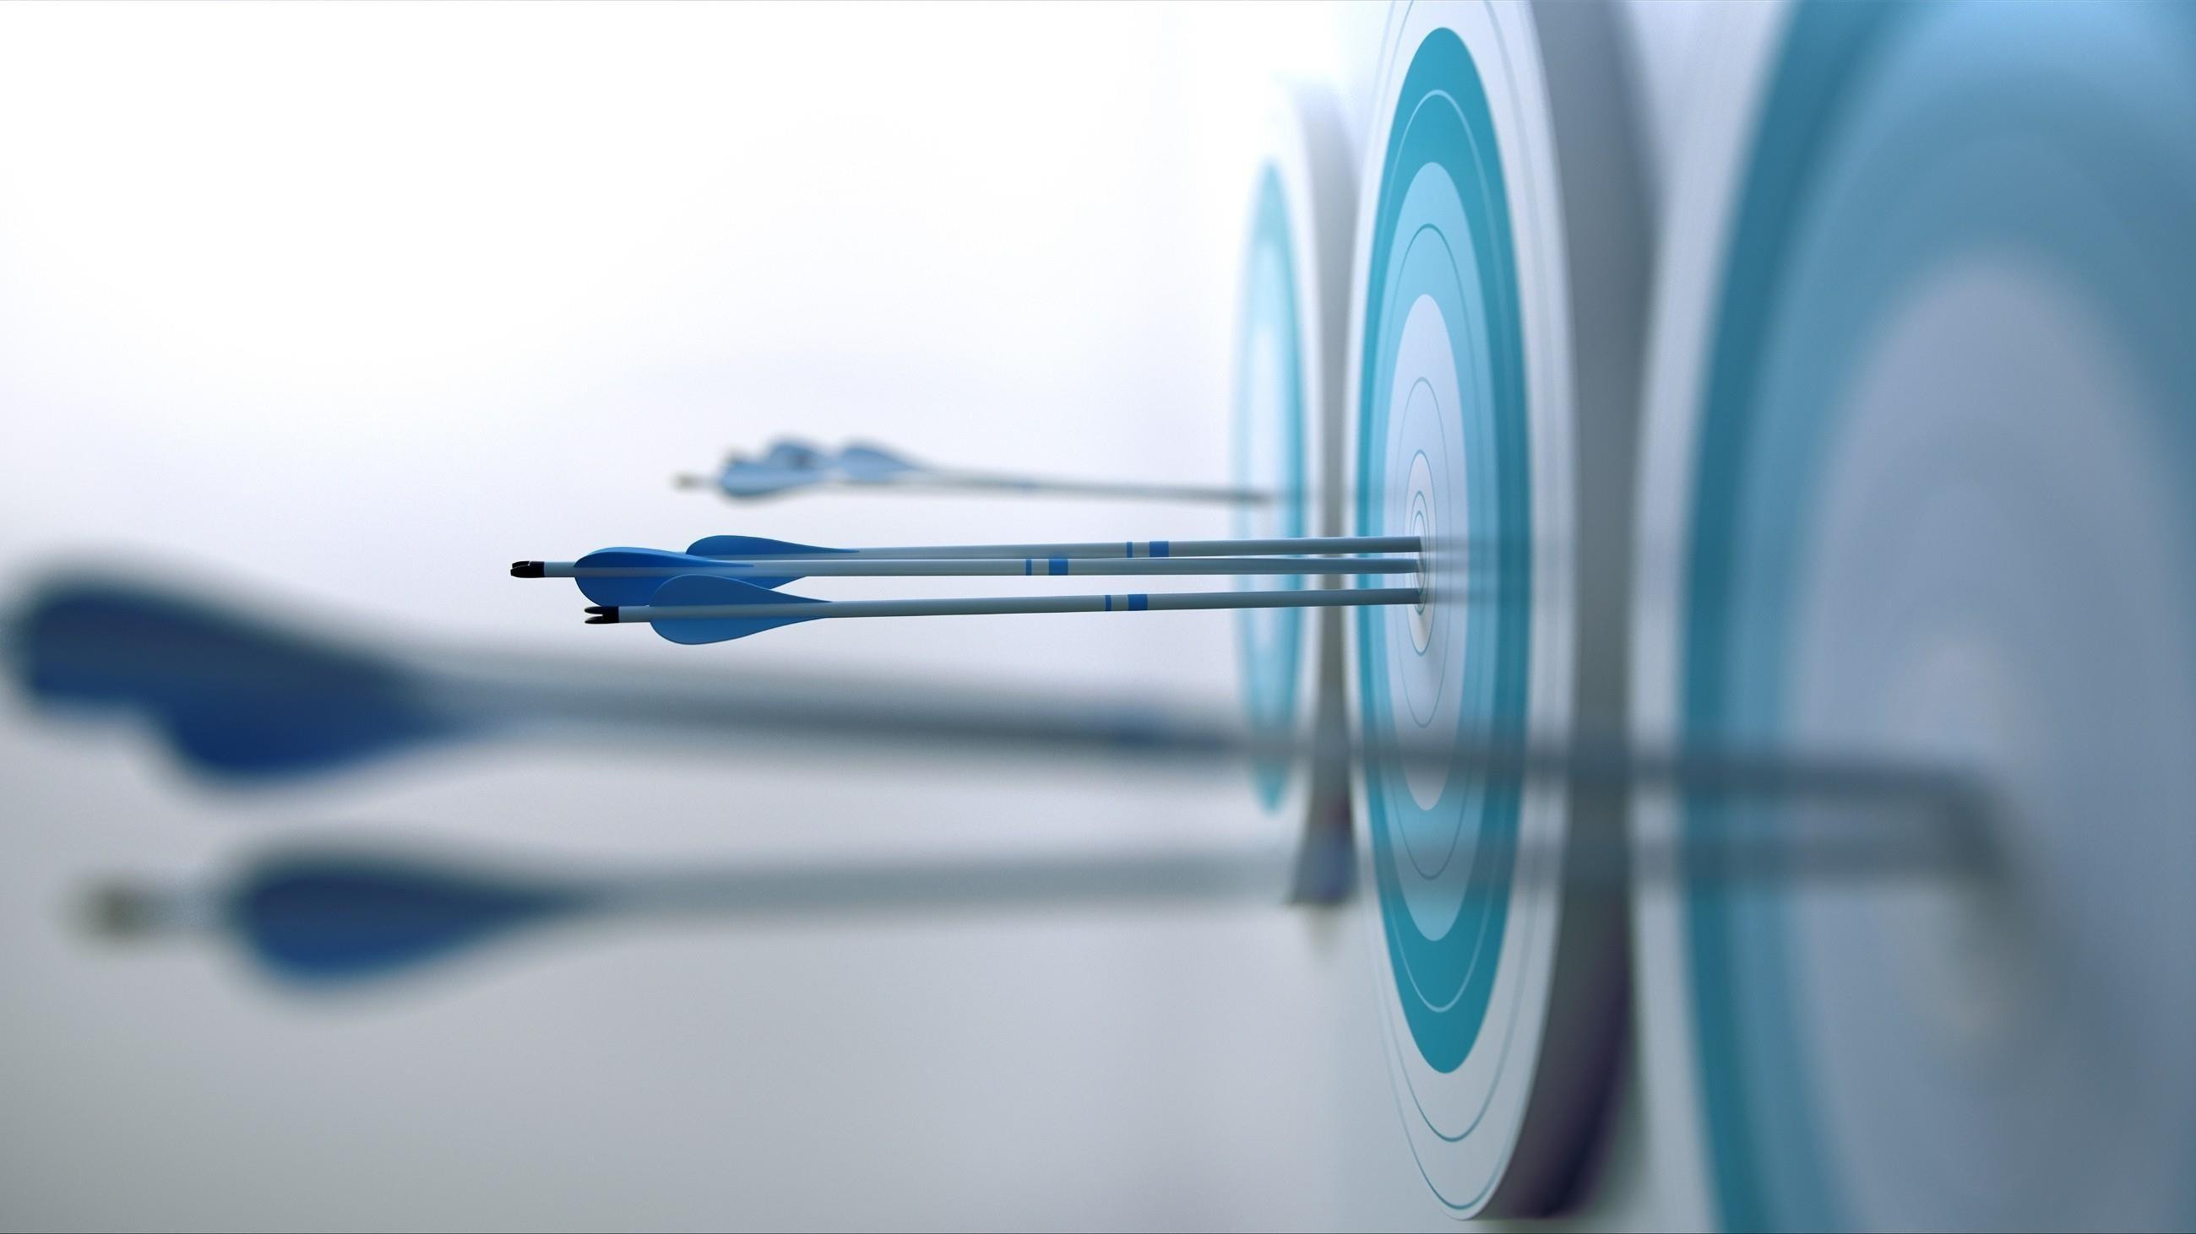

INVESTMENT REQUIRED

24
MIO

TECHNOLOGY AND PLANT ENGINEERING 13 MIO
LOCATION 4 MIO
MEANS OFTRANSPORT 1 MIO
MARKETING 2 MIO
TEAM 2 MIO
R&D 1 MIO

IT 1 MIO

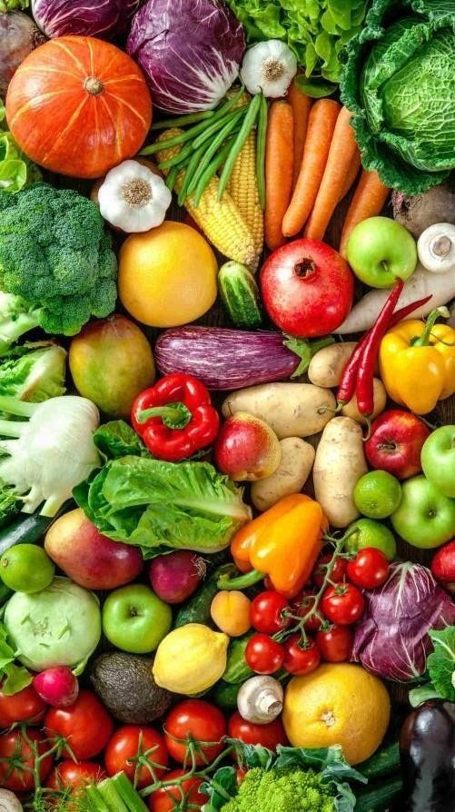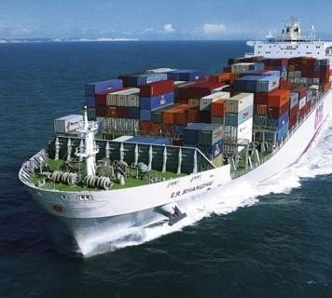
SAVING ON WATER WASTE
SALE OF CULTIVATED PRODUCT KM0
SAVING ON IMPORTS
PROFITS
PROFITS

LEGAL
GENERAL INFORMATION

The AQUA token does not have the legal qualification of a security, since it does not give any rights to dividends or interests.
The sale of AQUA tokens is final and non-refundable.
AQUA tokens are not shares and do not give any right to participate to the general meeting of CERVIERO.
AQUA tokens cannot have a performance or a particular value outside the AQUA Platform. AQUA tokens shall therefore not be used or purchased for speculative or investment purposes.
The purchaser of AQUA tokens is aware that national securities laws, which ensure that investors are sold investments that include all the proper disclosures and are subject to regulatory scrutiny for the investors' protection, are not applicable. Anyone purchasing AQUA tokens expressly acknowledges and represents that she/he has carefully reviewed this white paper and fully understands the risks, costs and benefits associated with the purchase of AQUA.

KNOWLEDGE REQUIRED

The purchaser of AQUA tokens undertakes that she/he understands and has significant experience of cryptocurrencies, blockchain systems and services, and that she/he fully understands the risks associated with the crowdsale as well as the mechanism related to the use of cryptocurrencies (incl. storage). CERVIERO shall not be responsible for any loss of AQUA tokens or situations making it impossible to access AQUA tokens, which may result from any actions or omissions of the user or any person undertaking to acquire AQUA tokens, as well as in case of hacker attacks.

RISK

Acquiring AQUA tokens and storing them involves various risks, in particular the risk that CERVIERO may not be able to launch its operations and develop its blockchain and provide the services promised. Therefore, and prior to acquiring AQUA tokens, any user should carefully consider the risks, costs and benefits of acquiring AQUA tokens in the context of the crowdsale and, if necessary, obtain any independent advice in this regard. Any interested person who is not in the position to accept or to understand the risks associated with the activity (incl. the risks related to the non- development of the AQUA platform) or any other risks as indicated in the Terms & Conditions of the crowdsale should not acquire AQUA tokens.

IMPORTANT DISCLAIMER

This white paper shall not and cannot be considered as an invitation to enter into an investment. It does not constitute or relate in any way nor should it be considered as an offering of securities in any jurisdiction.

This white paper does not include or contain any information or indication that might be considered as a recommendation or that might be used as a basis for any investment decision. AQUA tokens are just utility tokens which can be used only on the AQUA platform and are not intended to be used as an investment. The offering of AQUA tokens on a trading platform is done in order to allow the use of the AQUA platform and not for speculative purposes.

The offering of AQUA tokens on a trading platform does not change the legal qualification of the tokens, which remain a simple means for the use of the AQUA platform and are not a security. CERVIERO is not to be considered as an advisor in any legal, tax or financial matters. Any information in the white paper is provided for general information purposes only and CERVIERO does not provide any warranty as to the accuracy and completeness of this information.

CERVIERO is not a financial intermediary according to Switzerland law and is not required to obtain any authorization for Anti Money Laundering purposes. Acquiring AQUA tokens shall not grant any right or influence over CERVIERO organization and governance to the Purchasers.
Regulatory authorities are carefully scrutinizing businesses and operations associated to cryptocurrencies in the world. In that respect, regulatory measures, investigations or actions may impact CERVIERO business and even limit or prevent it from developing its operations in the future. Any person undertaking to acquire AQUA tokens must be aware of the CERVIERO business model, the white paper or terms and conditions may change or need to be modified because of new regulatory and compliance requirements from any applicable laws in any jurisdictions. In such a case, purchasers and anyone undertaking to acquire AQUA tokens acknowledge and understand that neither CERVIERO nor any of its affiliates shall be held liable for any direct or indirect loss or damage caused by such changes.

CERVIERO will do its utmost to launch its operations and develop the AQUA platform. Anyone undertaking to acquire AQUA tokens acknowledges and understands that CERVIERO does not provide any guarantee that it will manage to achieve it. They acknowledge and understand therefore that CERVIERO (incl. its bodies and employees) assumes no liability or responsibility for any loss or damage that would result from or relate to the incapacity to use AQUA tokens, except in case of intentional misconduct or gross negligence.

REPRESENTATION AND WARRANTIES

By participating in the crowdsale, the purchaser agrees to the above and in particular, they represent and warrant that they:
  - have read carefully the terms and conditions attached to the white paper; agree to their full contents and accept to be legally bound by them;
  - are authorized and have full power to purchase AQUA tokens according to the laws that apply in their jurisdiction of domicile;
  - are neither a US citizen or resident;
  - live in a jurisdiction which allows CERVIEROto sell AQUA tokens through a crowdsale without requiring any local authorization;
  - are familiar with all related regulations in the specific jurisdiction in which they are based and that purchasing cryptographic tokens in that jurisdiction is not prohibited, restricted or subject to additional conditions of any kind;
  - will not use the crowdsale for any illegal activity, including but not limited to money laundering and the financing of terrorism;
  - have sufficient knowledge about the nature of the cryptographic tokens and have significant experience with, and functional understanding of, the usage and intricacies of dealing with cryptographic tokens and currencies and blockchain-based systems and services;
  - purchase AQUA tokens because they wish to have access to the AQUA platform;
  - are not purchasing AQUA tokens for the purpose of speculative investment or usage; GOVERNING LAW AND ARBITRATION
Any dispute or controversy arising from or under the crowdsale shall be resolved by arbitration in accordance with the Switzerland Rules of International Arbitration of the UAE Chamber of Commerce in force on the date when the Notice of Arbitration is submitted in accordance with these Rules. The arbitration panel shall consist of one arbitrator only. The seat of the arbitration shall be Switzerland. The arbitral proceedings shall be conducted in English.

TEAM

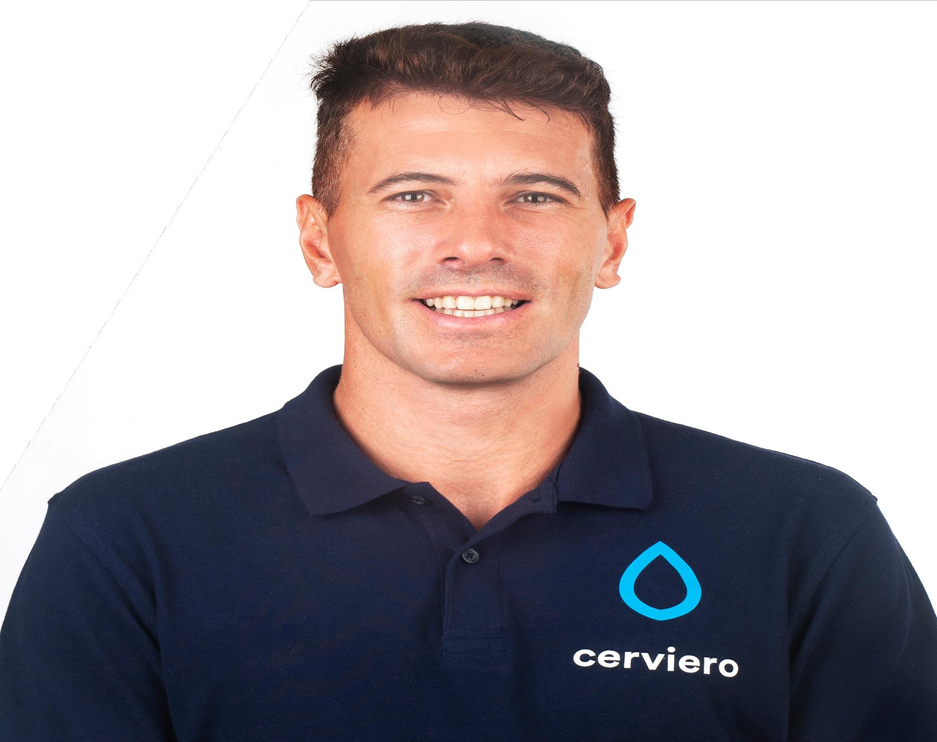
ANTONELLO CERVIERO

CEO & FOUNDER

ENTREPRENEUR WITH EXPERIENCE INTHE AGRICULTURAL FIELD AND LOVER OF THE FORMATION AND INNOVATION,AS IT IS BLOCKCHAIN TODAY. STRUCTURED AND ORGANISED PERSON, ABLE TO EFFICIENTLY PLAN AND MANAGE TIME. DEEPLY MOTIVATED TO WORK IN INTERNATIONAL ENVIRONMENTS.

